1.1P: Preparing for OOP – Answer Sheet

1. Explain the following terminal instructions:
   1. cd: cd stands for “change directory”. It allows you to change your file directory/location by stating “cd” and the file location.
   2. ls: ls means list files, it allows you to see all the files the directory you are currently in
   3. pwd: pwd stands for “print working directory”, and it tells you the current directory you are in.
2. Consider the following kinds of information, and suggest the most appropriate data type to store or represent each:

|  |  |
| --- | --- |
| Information | Suggested Data Type |
| A person’s name | string |
| A person’s age in years | int |
| A phone number | int |
| A temperature in Celsius | double |
| The average age of a group of people | double |
| Whether a person has eaten lunch | bool |

1. Aside from the examples already provided in question 2, come up with an example of information that could be stored as:

|  |  |
| --- | --- |
| Data type | Suggested Information |
| String | Names of restaurants |
| Integer | Number of Redbull’s consumed for exams |
| Float | The average exam scores |
| Boolean | Whether someone has worked out today |

1. Fill out the last two columns of the following table, evaluating the value of each expression and identifying the data type the value is most likely to be:

|  |  |  |  |
| --- | --- | --- | --- |
| Expression | Given | Value | Data Type |
| 6 |  | 6 | int |
| True |  | True | Bool |
| a | a = 2.5 | 2.5 | float |
| 1 + 2 * 3 |  | 7 | int |
| a and False | a = True | False | Bool |
| a or False | a = True | True | Bool |
| a + b | a = 1  b = 2 | 3 | int |
| 2 * a | a = 3 | 6 | int |
| a * 2 + b | a = 2.5 b = 2 | 7 | int |
| a + 2 * b | a = 2.5  b = 2 | 6.5 | float |
| (a + b) * c | a = 1  b = 1  c = 5 | 10 | int |
| “Fred” + “ Smith” |  | “Fred Smith” | String |
| a + “ Smith” | a = “Wilma” | “Wilma Smith” | String |

1. Using an example, explain the difference between **declaring** and **initialising** a variable.

The difference between the two is….*<finish the sentence>*

**Declaring a variable**

Declaring a variable is when you state that a variable of certain data type exists, but it has no value yet, memory is allocated at a specific location for the variable but it doesn’t hold any value yet.

**An example of this in C# is string name;**

**Initialising a variable**

Initialising a variable is when a value has been allocated to the variable after its been declared (or memory being allocated).

**An example of this in C# is string name = “Johnny Walker”;**

Now the variable has been initialised and holds a single value.

1. Explain the term **parameter**. Write some code that demonstrates a simple of use of a parameter. You should show a procedure or function that uses a parameter, and how you would call that procedure or function.

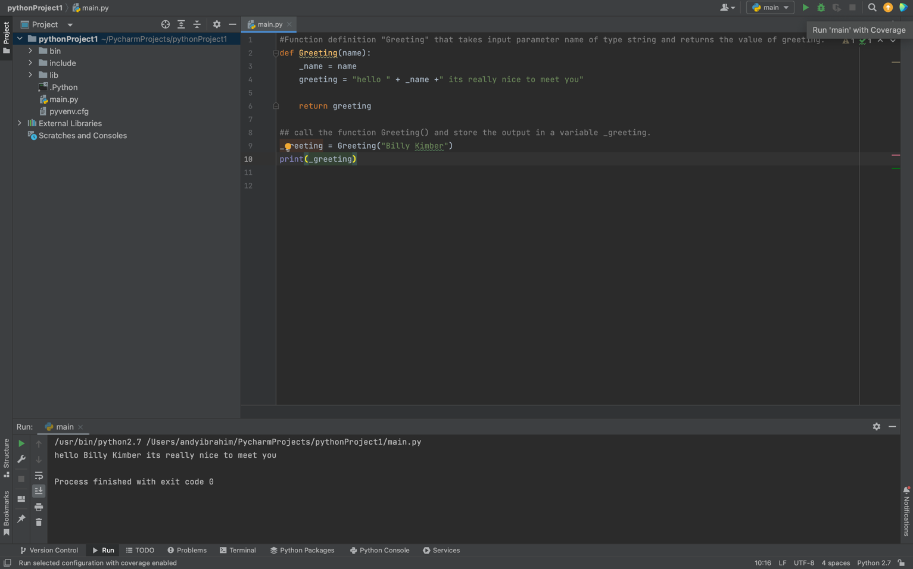A parameter is…*<When a function is declared, it may need to take some arguments as inputs for the function to compute what its intended to do. Those inputs for the function are referred to as parameters. They are a set of values that a function/method or process takes to complete the designated task. This process of a function having parameters is generalised so that the parameters can hold any value relative to what the function is going to compute, in saying that, even though the parameters are generalised, the domain or set of values the function can take is restricted. A function that takes a person’s name as input and prints out a greeting with their name cannot take an integer value, so any integers are forbidden from being inputted cause it wouldn’t make any sense. This is declared in the function definition >*

1. Using an example, describe the term **scope** as it is used in procedural programming (not in business or project management). Make sure you explain the different kinds of scope.

Scope is…*<When declaring variable or function names, the scope refers to the parts of the program where the function or variable names are valid and can be referred to. There are various scopes but the main once are global and local scopes. A global scope is when a variable or function name is declared at a location where the whole program has access to, this location is usually outside functions/methods etc. A local scope is when a variable or function is defined inside a function/method, thus it can only be accessed within the function/method and cannot be accessed outside the function.>*

1. Text

   Description automatically generatedIn a procedural style, in any language you like, write a function called Average, which accepts an array of integers and returns the average of those integers. Do not use any libraries for calculating the average. You must demonstrate appropriate use of parameters, returning and assigning values, and use of a loop. Note — just write the function at this point, we’ll *use* it in the next task. You shouldn’t have a complete program or even code that outputs anything yet at the end of this question.
2. In the same language, write the code you would need to call that function and print out the result.

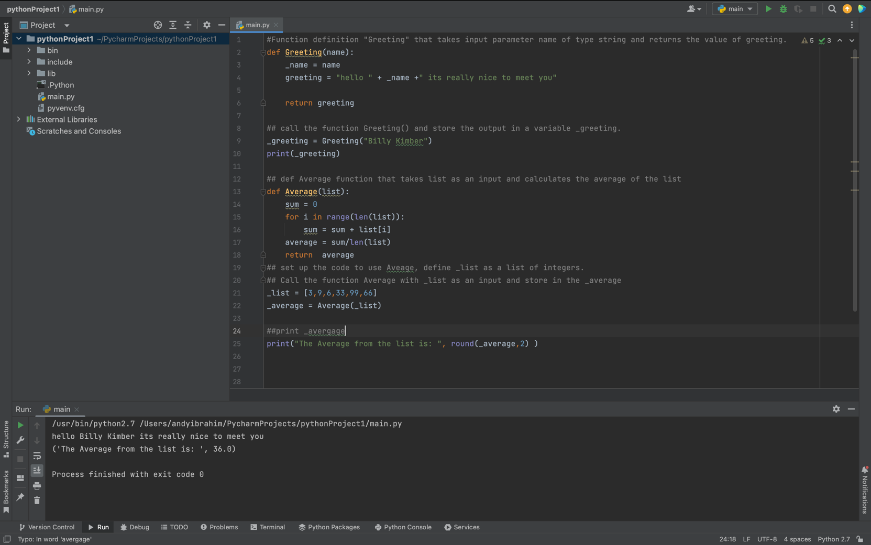

1. To the code from 9, add code to print the message “Double digits” if the average is above or equal to 10. Otherwise, print the message “Single digits”. Provide a screenshot of your program running.

